SQL Query Implementation for
E-Commerce Database
Project Title: E-Commerce Order Management Database System

Project Title : E-Commerce Order Management Database System
Student Name : Sarulatha P
Register Number : C4S38004
Department : B.Sc Artificial Intelligence
Course : Artificial intelligence (AI)
Academic Year : 2024 – 2027

SQL Query Implementation for
E-Commerce Database

1. SELECT Query
Display all products:
SELECT * FROM Product;

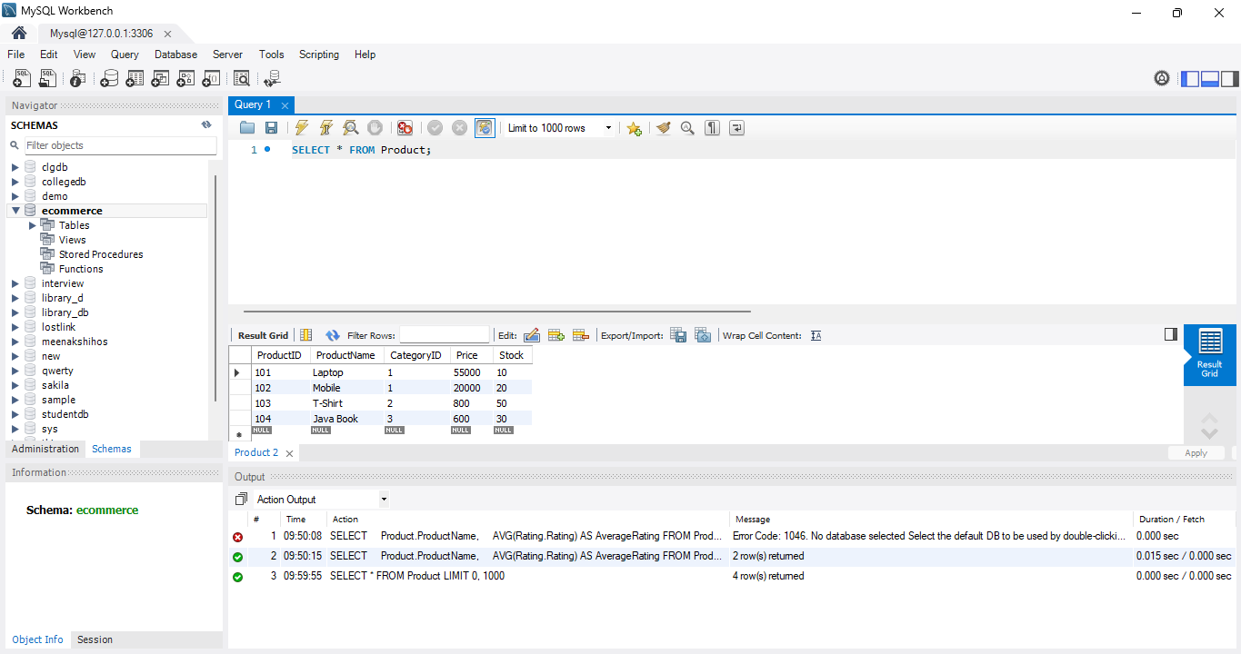

Display only product name and price:
SELECT ProductName, Price
FROM Product;

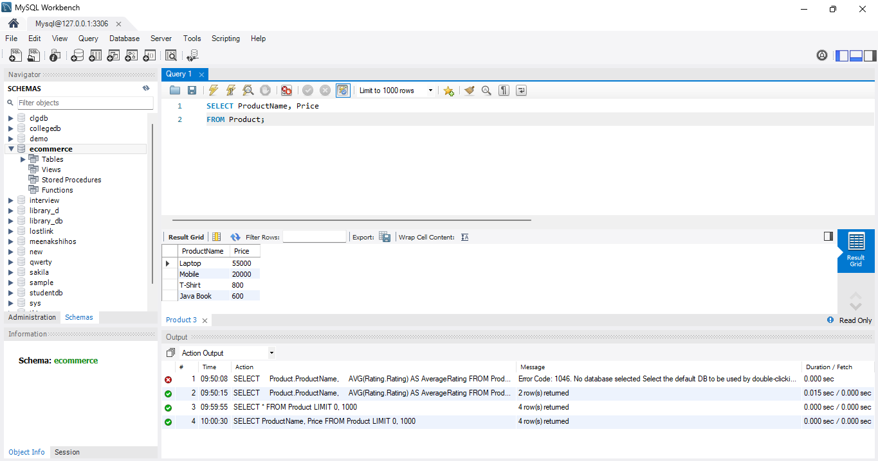

2. WHERE Query
Products costing more than ₹10,000:
SELECT * FROM Product
WHERE Price > 10000;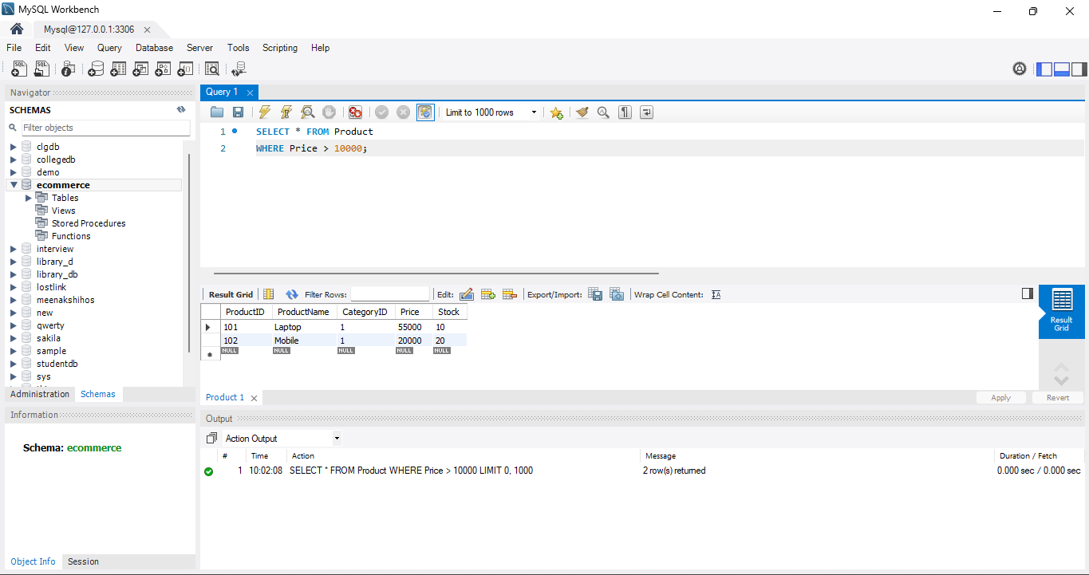
Products costing less than ₹5,000:
SELECT * FROM Product
WHERE Price < 5000;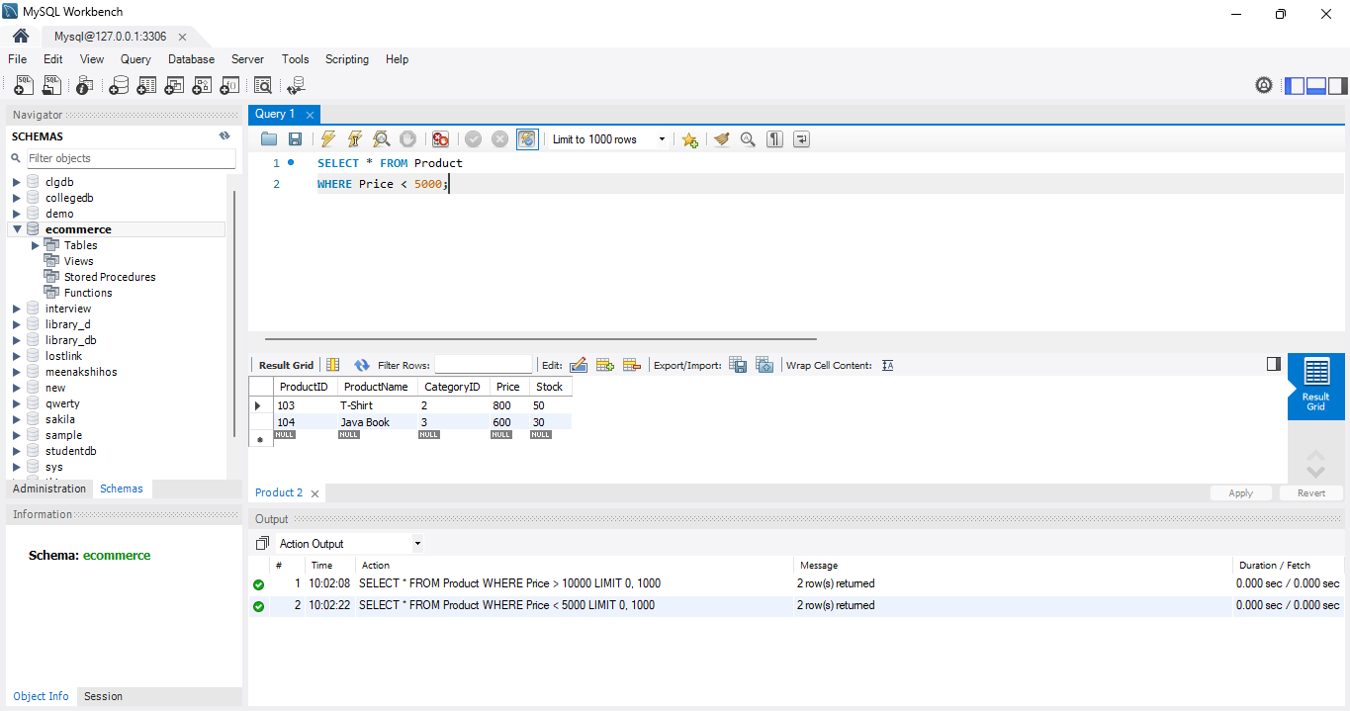
3. ORDER BY Query
Products from lowest to highest price:
SELECT * FROM Product
ORDER BY Price ASC;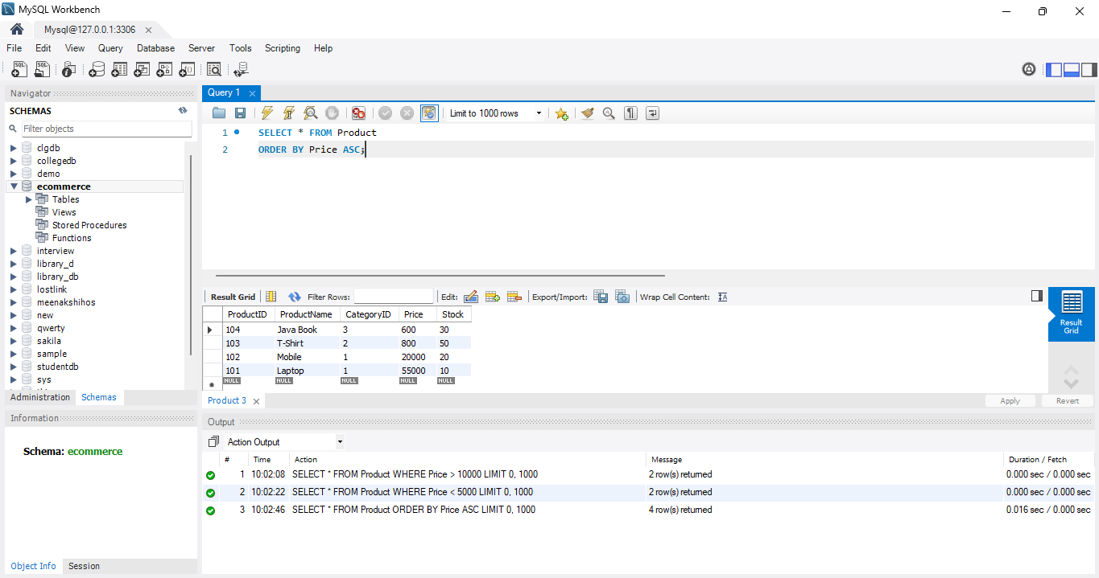
Products from highest to lowest price:
SELECT * FROM Product
ORDER BY Price DESC;
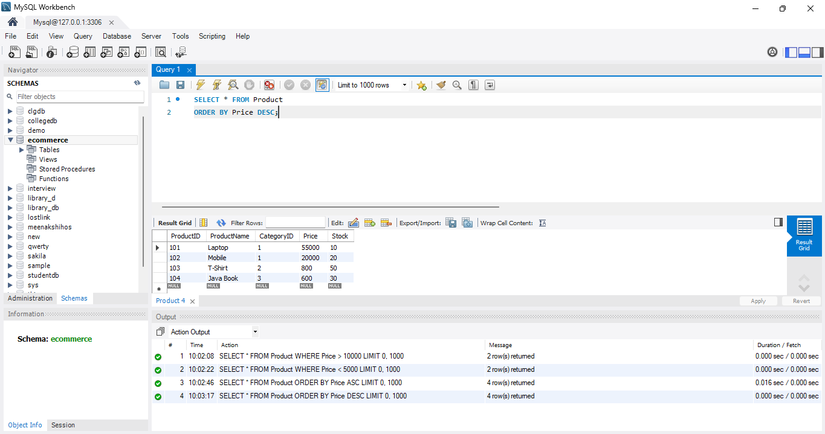
4. DISTINCT Query
Display different product categories:
SELECT DISTINCT CategoryID
FROM Product;
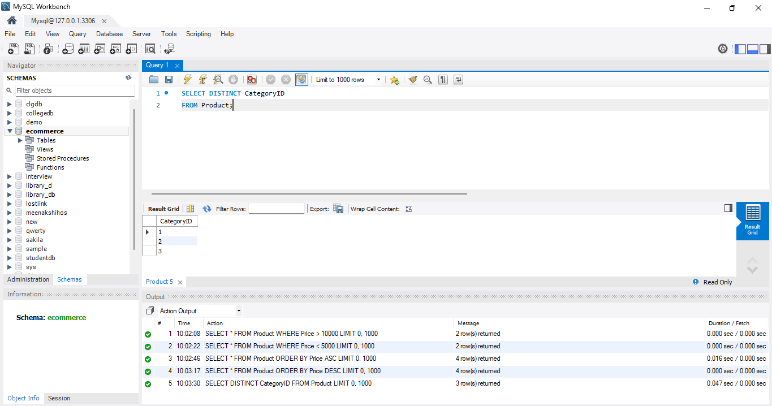
Display different payment methods:
SELECT DISTINCT PaymentMode
FROM Payment;
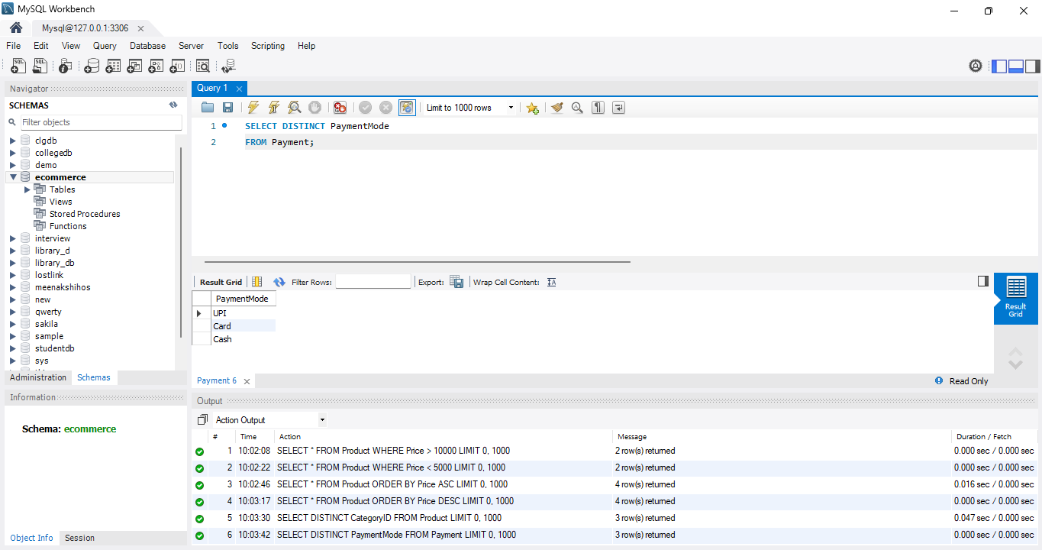

5. Search Products by Price
Products between ₹1,000 and ₹30,000:
SELECT * FROM Product
WHERE Price BETWEEN 1000 AND 30000;

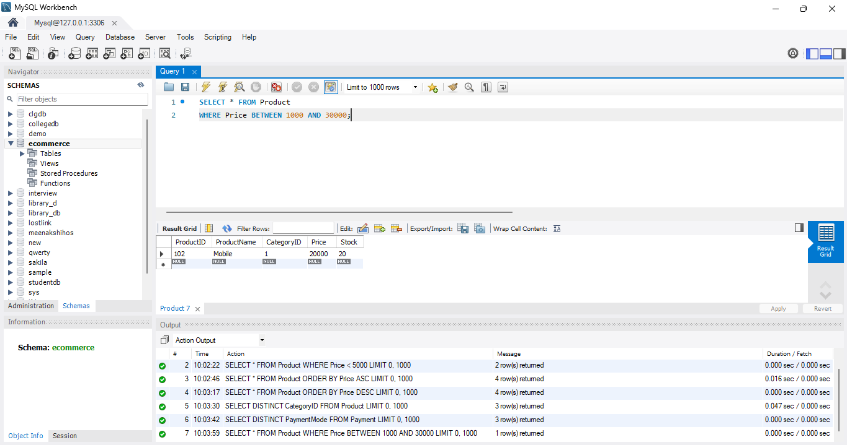

6. Search Products by Category
Display products from category 1:
SELECT * FROM Product
WHERE CategoryID = 1;

